L2 : More about factorization (B)

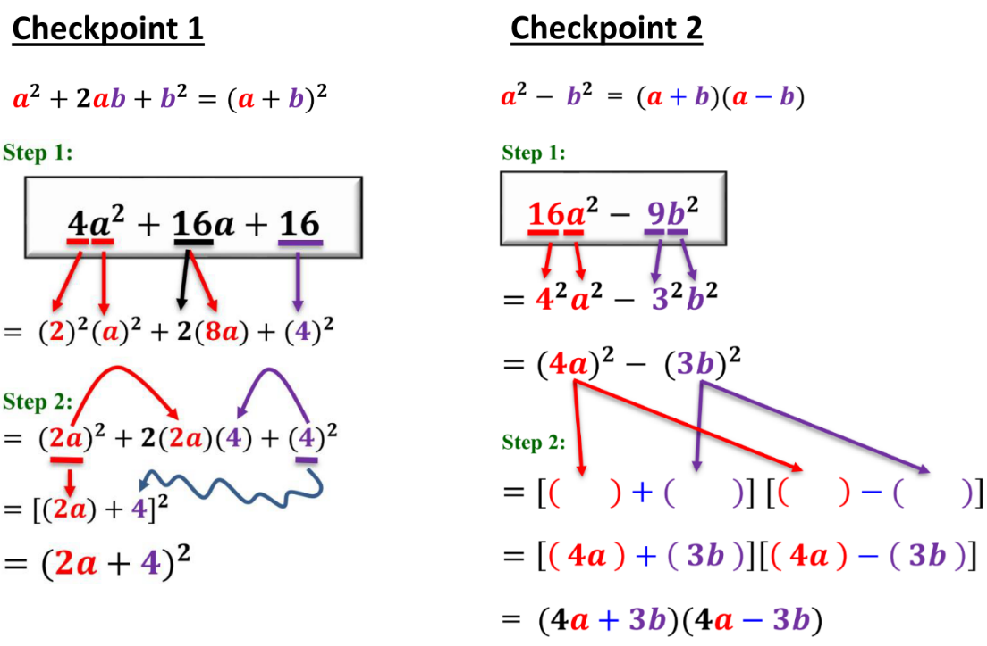

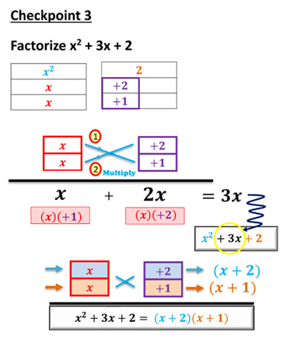

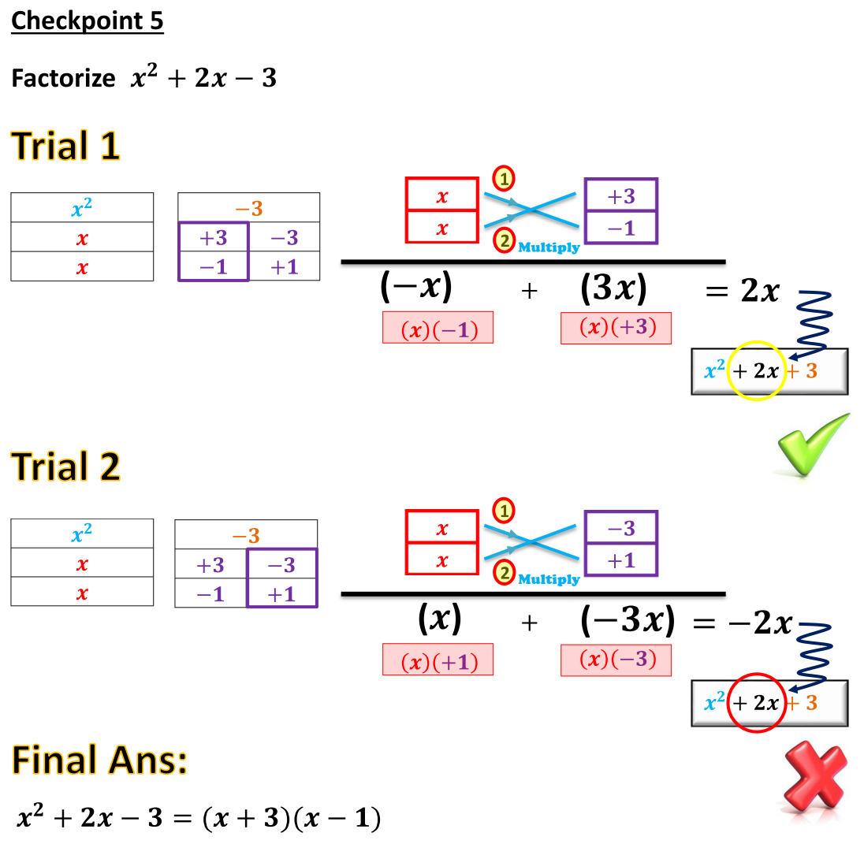

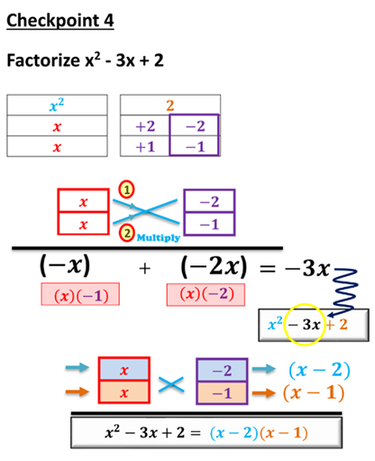

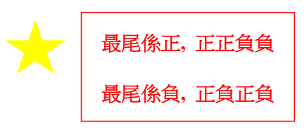

Let’s get started!

Factorize the following expressions.

1. a² + 24a + 95

3. c² − 13c − 90

5. 66 + w² + 17w

7. −32 − 4h + h²

9. 15p − p² − 44

11. 2s² − 26s + 72

2. b² − 48b + 176

4. d ² + 17d − 200

6. −6s + s² − 91

8. −42 + 11r + r²

10. −17n − n² − 72

12. 3t² − 12t − 63

Factorize the following expressions.
13. 7x² − 10x + 3

15. 4c² + 9c + 2

17.

19. $\text{5}f^{\text{2}}+\text{24}fg+\text{16}g^{\text{2}}$

21. (a)
(b)

23. (a) 7m² + 16mn + 4n²
(b) 7m² + 16mn + 4n² + 5m + 10n

14. 5y² − 11y + 2

16. 4s² − 11s + 6

18. $\text{3}p^{\text{2}}-\text{8}pq+\text{5}q^{\text{2}}$

20. .

22. (a)
(b)

24. (a) x² – 8x + 12
(b) xy – x² – 6y + 8x – 12

Factorize the following expressions.
25. 4a² + 16a − 9

27. 22c² − 67c + 30

29. 21a² − 8ab − 4b²

31. $\text{10}p^{\text{2}}+\text{9}pq-\text{7}q^{\text{2}}$

33. 7m³n – 41m²n² – 6mn³

35. (a) 18x² – 3xy – 10y²
(b) 24x – 20y – 18x² + 3xy + 10y²

26. 24b² − b − 10

28. 9d ² − 4d − 5

30. 4m² + 4mn − 15n²

32.

34. 60b² – 24b⁴ + 4b³

36. (a) x²y – 4xy² – 32y³
(b) x²y + 2x² + 16xy – 4xy² + 32y² – 32y³

Factorize the following expressions.
37.

39. (9p − 12)(6p + 6) − 15p

41.

43.

45.

38. .

40.

42.

44.

46.

47. Factorize
(a) ,
(b) ,
(c)

49. Factorize
(a) ,
(b) ,
(c) .

51. Factorize
(a) ,
(b) ,
(c) .

48. Factorize
(a) ,
(b) ,
(c) .

50. Factorize
(a) ,
(b) ,
(c) .

52. Factorize
(a) ,
(b) ,
(c) .

Final Boss!

53. (a) Factorize .
(b) Hence, factorize
(i) ,
(ii) .

55. (a) Factorize .
(b) Hence, factorize .

57. (a) Factorize .
(b) Hence, factorize .

54. (a) Factorize .
(b) Hence, factorize
(i) ,
(ii) .

56. (a) Factorize .
(b) Hence, factorize .

58. (a) Factorize .
(b) Hence, factorize .

59. (a) Factorize .
(b) Hence, factorize .

61. (a) Factorize .
(b) Hence, simplify .

63. (a) Factorize .
(b) Hence, simplify .

60. (a) Factorize .
(b) Hence, factorize .

62. (a) Factorize
(i) ,
(ii) .
(b) Hence, simplify .

64. (a) Factorize .
(b) Hence, simplify .

